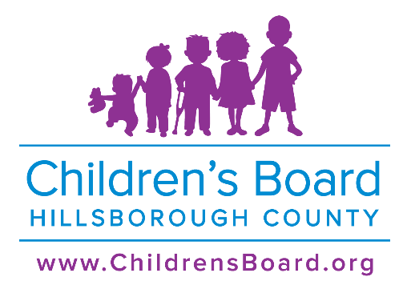
PRO 2024 – 10 Request for Proposals (RFP)
Level ( 3) Leading Grant-Exhibit Space at Children’s Board Family Resource Center in Plant City
Attachment (#1) – Cover Sheet

“Organization Legal Name” must match agency name listed on the Florida Department of State Division of Corporation website: http://sunbiz.org/.
1. Proposer Organization Legal Name:
2. CEO/ Executive Director Name:
3. Organization Address:
4. City: | 5. State: | 6. Zip Code:
7. Organization Phone Number: | 8. Organization Website:
9. Organization Type: ______ Not for Profit (Incorporation date: ____/____/______)
______ Government ______ Other (Please specify):
10. Proposer’s Current Organization Total Budget: $
11. IRS Determination: ______ 501c3 ______ Other (Please specify):
12. Registered Florida Charitable Organization: ______ Yes ______ No
Program Information:
13. Proposed Program Name:
14. Proposed Focus Age Group/Target Population:
15. Proposed Service Geographic Area:
16. Proposed Program Summary: Describe proposed program services for the general public’s understanding. (50 words or less)
17. A) Amount of Request from CBHC for First Year = $
B) Number of unduplicated participants to be served in First Year:
Adults ____ Children ____ Total: ____
C) Calculate and indicate the Unit Cost per Program Participant for First Year = $
(Amount of Request from CBHC ÷ Total Number of Adults and/or Children to be Served)
18. A) Amount of Request from CBHC for Second Year = $
B) Number of unduplicated participants to be served in Second Year:
Adults ____ Children ____ Total: ____
C) Calculate the Unit Cost per Program Participant for Second Year = $
(Amount of Request from CBHC ÷ Total Number of Children and/or Adults to be Served)
19. Proposed Program Focus Area (check all that apply):
______ Family Support
Grant Contact Information:
20. Grant Contact Person Name:
21. Grant Contact Person Phone Number: | 22. Grant Contact Person Email:

Hillsborough County BOCC District:
Refer to the Hillsborough County Website: http://www.hillsboroughcounty.org/en/government/board-of-county-commissioners and click on Find My Elected Official to determine in which Board of County Commission district the Proposer Organization resides.
23. Commission District:
_____ 1 _____ 2 _____ 3 _____ 4 (District 5, 6, &7 are at large seats)
24. If Proposer Organization is located within the city limit, please indicate:
_____ City of Tampa _____ City of Temple Terrace _____ City of Plant City _____ Not Applicable
SIGNATURES:
- I have read and can comply with the CBHC General Terms and Conditions (Appendix #2).
  - I do hereby certify to the above statements that all facts, figures, and representations made in this proposal and supporting documents are true and correct.
  - I certify that I have been duly authorized to act as the authorized representative of the Proposer Organization in connection with filling out this proposal and have obtained any necessary authorization from the Proposer’s governing body for the submission of this proposal.
- I acknowledge that this proposal and all additional documents submitted become the property of the Children’s Board and will become public record subject to the provisions of Chapter 119, Florida Statutes.

__________________________________ ______________________________________
Signature of Authorized Official Signature of Board Chair
__________________________________ ______________________________________
(Printed Name) (Printed Name)
Date: _________________ Date: ________________
Title: ______________________________

