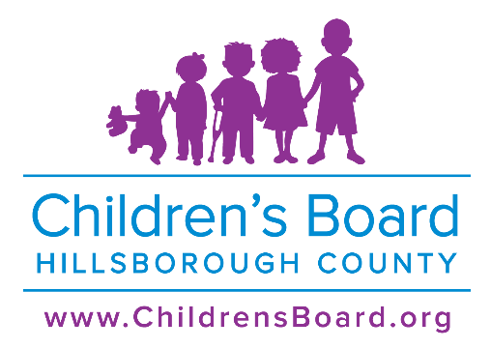
PRO 2024 – 09 Intent to Negotiate (ITN)
Uniting Grants
Self Sufficiency Case Management
Attachment (#1) – Cover Sheet
Focus Area: Family Support

jjjjjjj
“Organization Legal Name” must match agency name listed on the Florida Department of State Division of Corporation website: http://sunbiz.org/.
1. Proposer Organization Legal Name:
2. CEO/ Executive Director Name:
3. Organization Address:
4. City: | 5. State: | 6. Zip Code:
7. Organization Phone Number: | 8. Organization Website:
9. Proposer’s Organization Current Total Budget: $
10. Organization Type: ______ Not for Profit (Incorporation date: ____/____/______)
______ Government ______ Other (Please specify):
11. IRS Determination: ______ 501c3 ______ Other (Please specify):
12. Registered Florida Charitable Organization: ______ Yes ______ No
Program Information:
13. Proposed Program Name:
14. Proposed Focus Age Group/Target Population:
15. Proposed Program Summary: Describe proposed program services (not goals) for the general public’s understanding. (50 words or less)
16. Proposed Service Geographic Area (only check one):
___ 33603 and 33610 (up to $100,000)
or
___ 33619 (up to $50,000)
17. A) Amount of Request from CBHC for Year One (3 months) = $
B) Number of unduplicated participants to be served in Year One:
Adults ____ Children ____ Total: ____
C) Calculate and indicate the Unit Cost per Program Participant for Year One = $
(Amount of Request from CBHC ÷ Total Number of Adults and/or Children to be Served)
18. A) Annualized Amount for Year Two = $
B) Number of unduplicated participants to be served in Year Two:
Adults ____ Children ____ Total: ____
C) Calculate the Unit Cost per Program Participant for Year Two = $
(Amount of Request from CBHC ÷ Total Number of Children and/or Adults to be Served)
Grant Contact Information:
19. Grant Contact Person Name:
20. Grant Contact Person Phone Number: | 21. Grant Contact Person Email:
Hillsborough County BOCC District:
22. Refer to the Hillsborough County Website: http://www.hillsboroughcounty.org/en/government/board-of-county-commissioners and click on Find My Elected Official to determine in which Board of County Commission district the Proposer Organization resides. Commission District: _____ 1 _____ 2 _____ 3 _____ 4
(District 5, 6, &7 are at large seats)
23. If Proposer Organization is located within a city limit, please indicate:
_____ City of Tampa _____ City of Temple Terrace _____ City of Plant City _____ Not Applicable
SIGNATURES:
- I have read and can comply with the CBHC General Terms and Conditions (Appendix #2).
  - I do hereby certify to the above statements that all facts, figures, and representations made in this proposal and supporting documents are true and correct.
  - I certify that I have been duly authorized to act as the authorized representative of the Proposer Organization in connection with filling out this proposal and have obtained any necessary authorization from the Proposer’s governing body for the submission of this proposal.
- I acknowledge that this proposal and all additional documents submitted become the property of the Children’s Board and will become public record subject to the provisions of Chapter 119, Florida Statutes.

__________________________________ ______________________________________
Signature of Authorized Official Signature of Board Chair
__________________________________ ______________________________________
(Printed Name) (Printed Name)
Date: _________________ Date: ________________
Title: ______________________________

